# Did Coronavirus quarantine cause an uptick in people interested in birdwatching?

I would like to look at whether Covid quarantine in 2020 produced any prolonged changes in interest in birdwatching (one of my hobbies). Did folks stuck at home gain any further appreciation for nature outside their windows? Also did they stick with it?

I started by looking for general results on “bird feeder”. There was a definite uptick in search volume centered about May 2020, during the middle of quarantine.

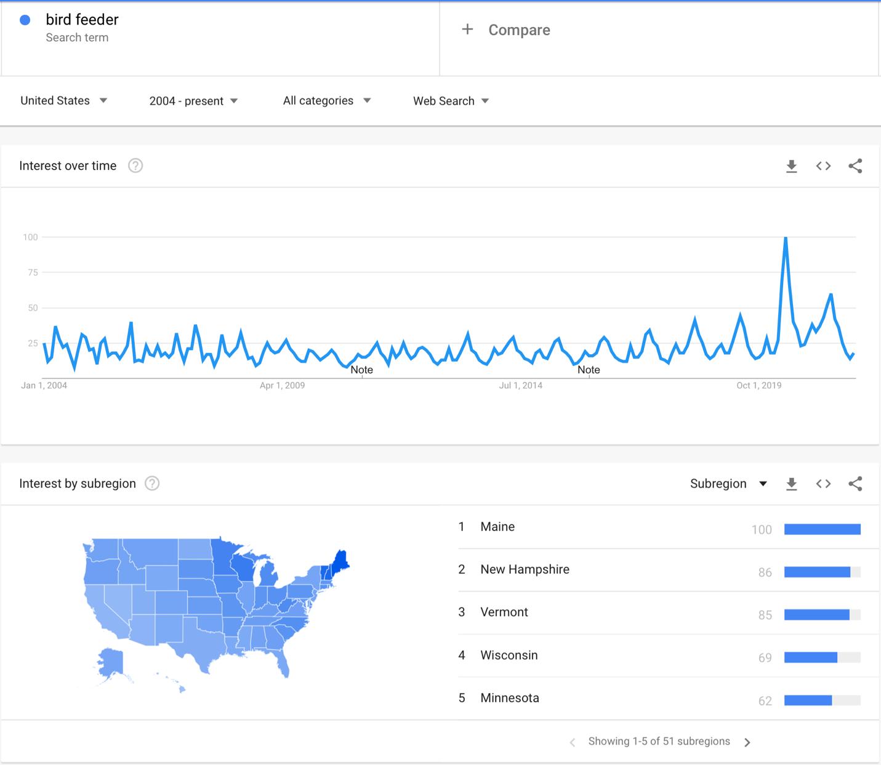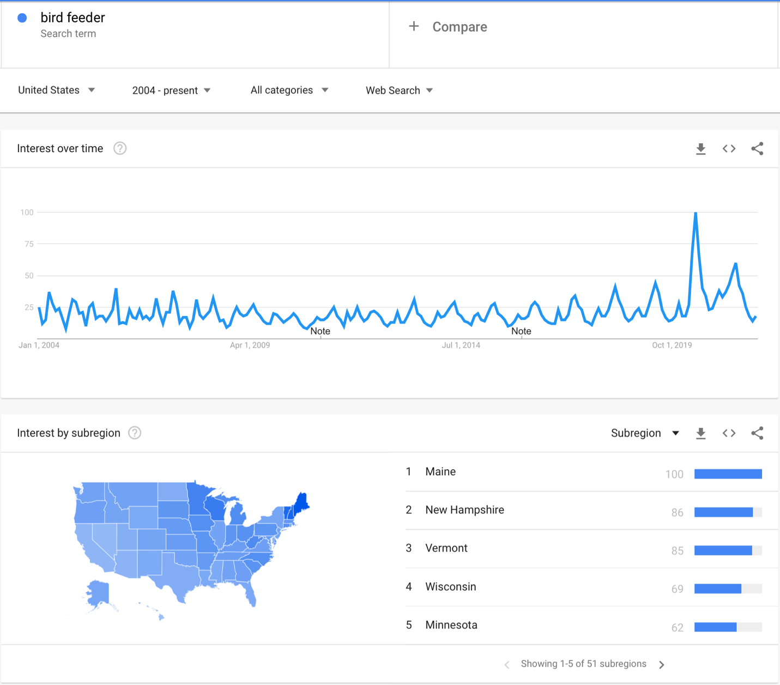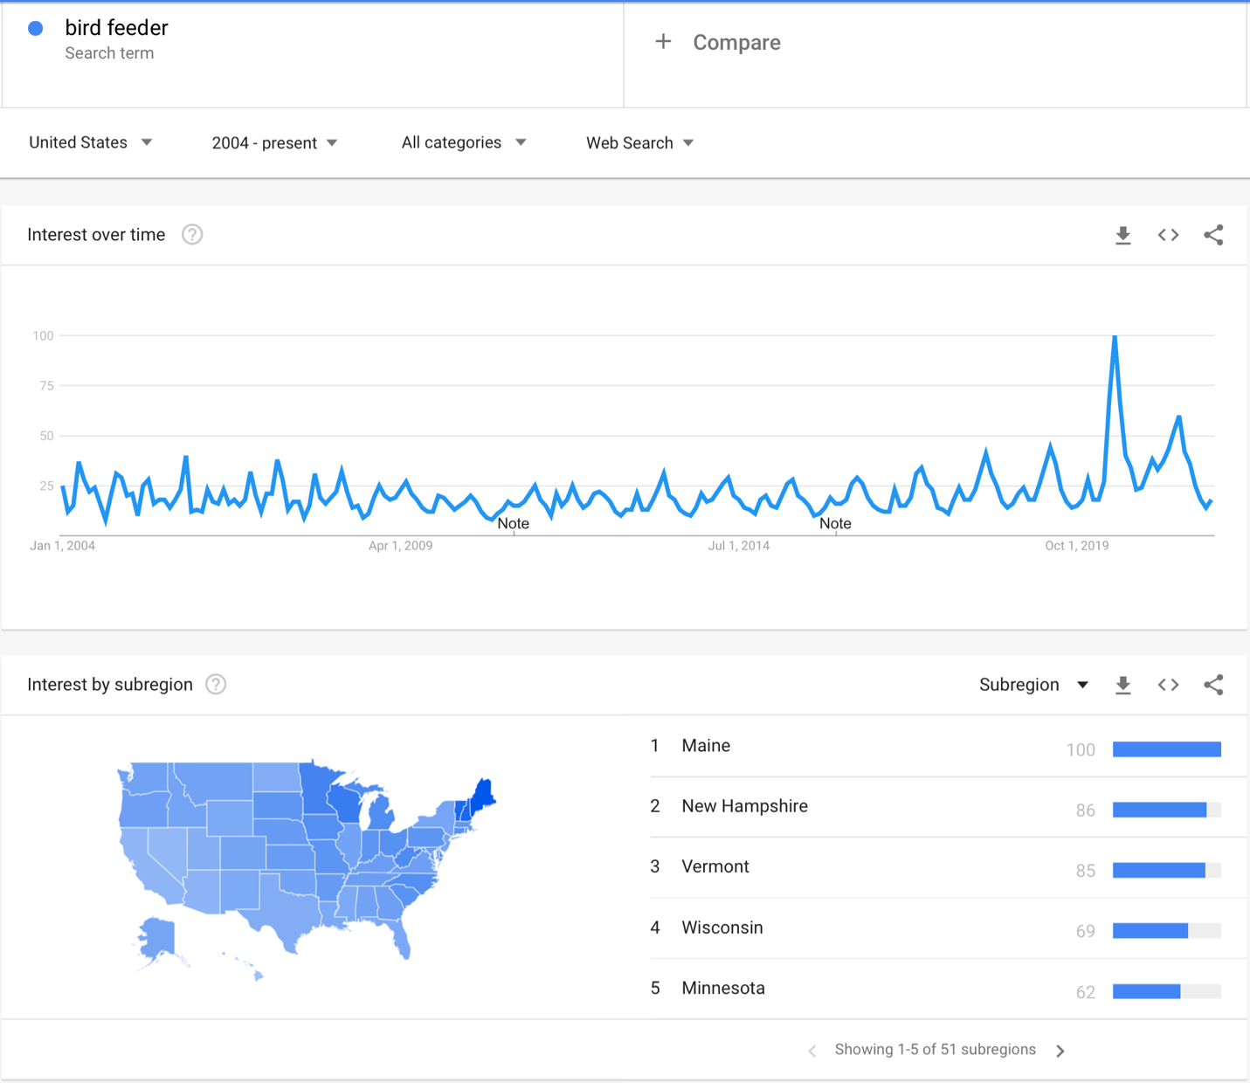

One thing that surprised me was how much higher interest in bird feeders was in Maine, New Hampshire, and Vermont. These are all known as outdoorsy states, but I would have expected some similarity with west coast states as well. I am not sure how to account for this difference in interest, so I’ll leave that alone for now.



Next, I decided to look at trends for “bird feeder” searches across years to account for seasonality. (Note: my years are out of order) 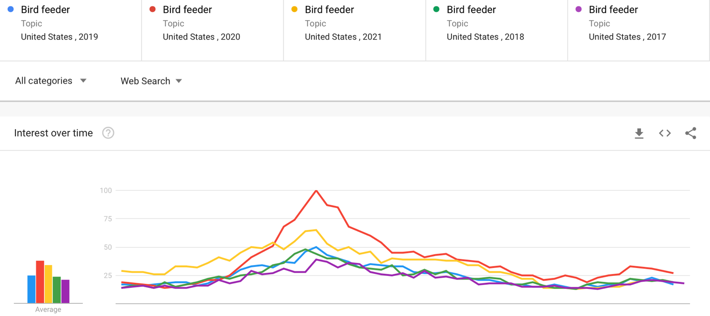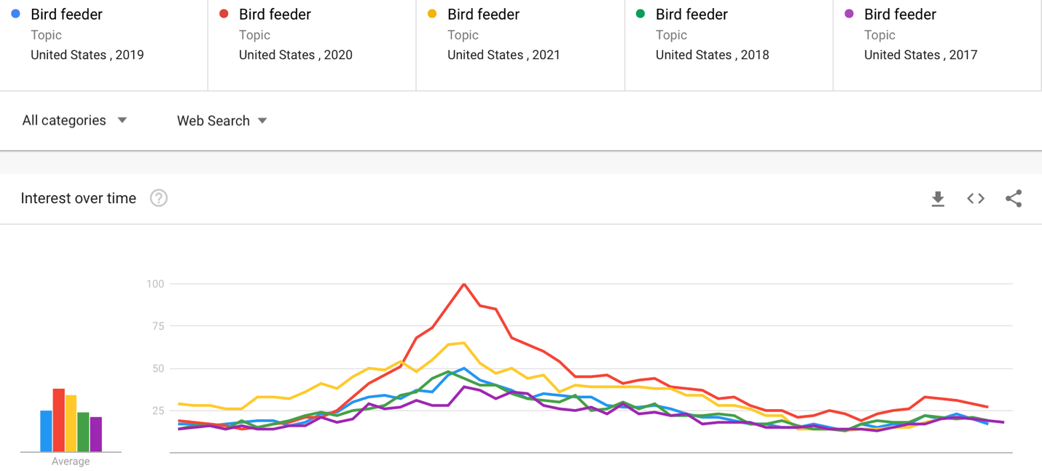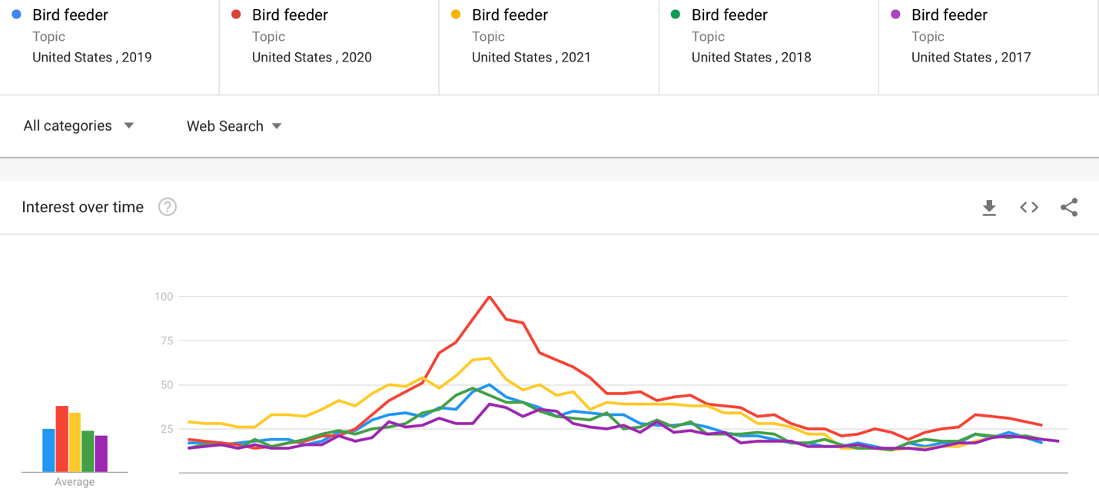

In this graph, we can see that there is a strong uptick in searches for 2020 (red), and that the uptick continues at a slightly lesser rate in 2021 (yellow), but is still higher than the other previous years. There also seems to have been a gradual increase year by year in interest in bird feeding in previous years (follow purple, green, and then blue) particularly in the summer months (March to October).

One of the things I wanted to see after that was are people continuing to use their feeder once they potentially get one. Once you buy the feeder, you don’t necessarily need to search for another one, but you do need to continue to fill it with bird seed. So I searched for “bird seed” and got this (years colored the same as before):

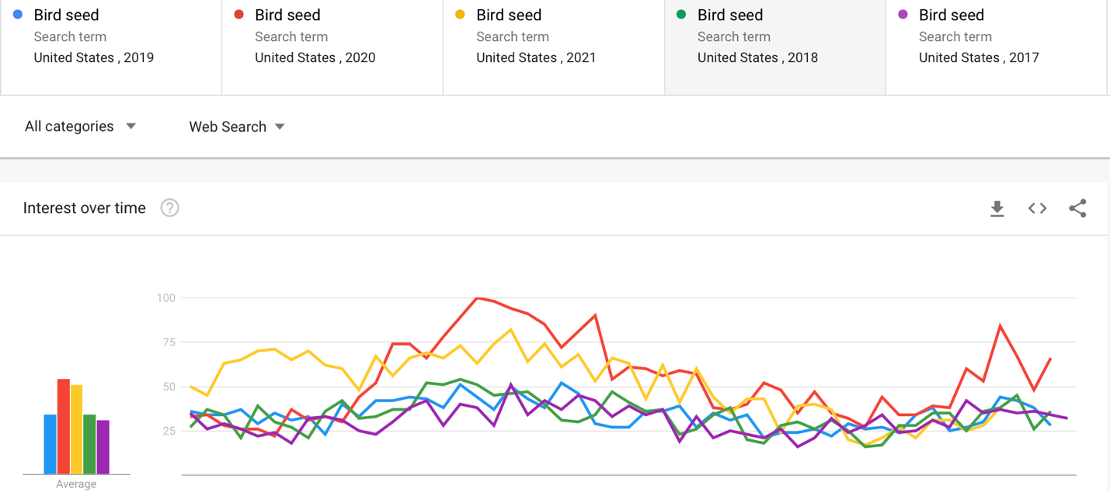



The graph is certainly messier than before, but you can still see there is a higher rate of searches for 2020 (red) and 2021 (yellow). People had to fill their feeders when they initially got them in May (hence the uptick there), and then there is a second brief surge in searches in winter 2020 (red) that continues into spring and summer of 2021 (yellow). It appears that searches have returned to previous baseline levels around the beginning of October of 2021. This may indicate that people who became interested in bird feeding during the pandemic quarantine are not as interested in continuing to feed birds when they are back to work and not home to enjoy them anymore.

I would like to continue pursuing interest in birdwatching for my term paper and explore other related search terms such as “birdwatching”, “bird identification”, tools of the trade such as “binoculars”, and birding location searches “hiking trails” to see if perhaps the quarantine stimulated an interest in birds in general and maybe got people to explore the outdoors more. Also, most importantly to me, did any increase in interest last beyond quarantine to perhaps foster a new life-long hobby?